**5.13 Use Case 13 – Advanced Search of Users**

**5.13.1 Fully Dressed Use Case**

|  |  |  |
| --- | --- | --- |
| Use Case ID: | UC13 | |
| Use Case Name: | Advanced Search of Users | |
| Created By: | Philip Lim | Last Updated By: Philip Lim |
| Date Created: | April 2, 2016 | Last Revision Date: April 2, 2016 |
| Actor(s): | Administrator | |
| Goal/Actor Goals: | Obtain access to data related to a user through advanced search criteria. | |
| Description/Summary: | An administrator wishes to gain access to information related to a user through advanced search criteria such as the user’s ID, username, first name, last name and net name. | |
| Preconditions: | * User must be logged in as an Administrator. | |
| Post-conditions: | A list of student(s) that fits the advanced search criteria and which information can be accessed and modified is displayed. | |
| Minimum Guarantee: | The system does not find any users matching the specified criteria and indicates that no results have been found. | |
| Basic Flow: | 1. Administrator indicates that an advanced search for users is to be performed. 2. System displays a set of advanced search field criteria form to be completed. 3. Administrator specifies the search criteria. 4. System displays a list of editable users matching the search criteria indicated by the administrator. | |
| Risk assessment: | Medium | |
| Importance assessment: | 2/5 | |

**5.13.2 System Sequence Diagram**

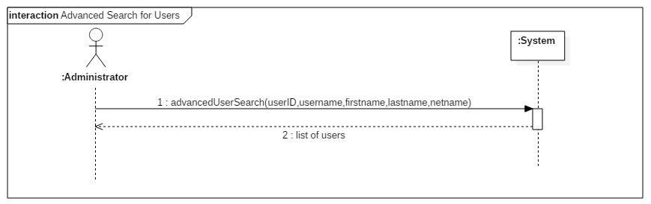

*Figure 5.13.1 Advanced Search for Users System Sequence Diagram*

**5.13.3 Contract Diagram**

|  |  |  |
| --- | --- | --- |
| Contract 13.1 | advancedUserSearch | |
| Created By: | Philip Lim | Last Updated By: Philip Lim |
| Date Created: | April 2, 2016 | Last Revision Date: April 2, 2016 |
| Operation: | advancedUserSearch(userID, username, firstname, lastname, netname) | |
| Cross-reference: | UC13 | |
| Preconditions: | * User is logged into the system as an Administrator. | |
| Post-conditions: | * A list of users corresponding to the specified search criteria is displayed to be consulted or modified. | |

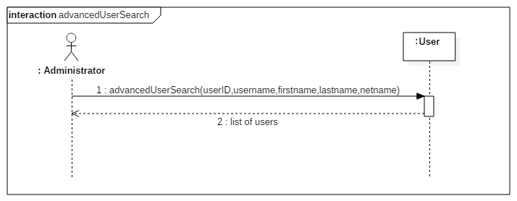

*Figure 5.13.2 advancedUserSearch contract diagram*

**5.14 Use Case 14 – View User**

**5.14.1 Fully Dressed Use Case**

|  |  |  |
| --- | --- | --- |
| Use Case ID: | UC14 | |
| Use Case Name: | View User | |
| Created By: | Philip Lim | Last Updated By: Philip Lim |
| Date Created: | April 2, 2016 | Last Revision Date: April 2, 2016 |
| Actor(s): | Administrator | |
| Goal/Actor Goals: | View information stored in the system about a user. | |
| Description/Summary: | An administrator wishes to view the profile summary that contains information about a user such as its ID, username, first name, last name, and net name. | |
| Preconditions: | * User must be logged in as an Administrator. * A user search result is displayed. * The user the administrator is looking for is listed in the search result. | |
| Post-conditions: | A set of information about the selected user is displayed for the administrator. | |
| Minimum Guarantee: | The set of information field is displayed but may contain empty field. | |
| Basic Flow: | 1. Administrator indicates that the information about a particular user displayed on a search result is to be consulted. 2. System retrieves information about the user and displays it in a table. | |
| Risk assessment: | Medium | |
| Importance assessment: | 3/5 | |

**5.14.2 System Sequence Diagram**

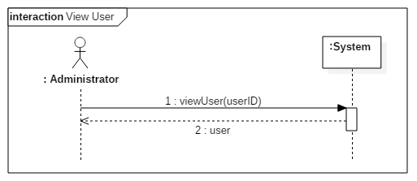

*Figure 5.14.1 View User System Sequence Diagram*

**5.14.3 Contract Diagram**

|  |  |  |
| --- | --- | --- |
| Contract 14.1 | viewUser | |
| Created By: | Philip Lim | Last Updated By: Philip Lim |
| Date Created: | April 2, 2016 | Last Revision Date: April 2, 2016 |
| Operation: | viewUser(userID) | |
| Cross-reference: | UC14 | |
| Preconditions: | * User is logged into the system as an Administrator. * A search result is displayed * The user that corresponds to the userID is displayed on the search result | |
| Post-conditions: | * Data of the user corresponding to the passed userID is made available for the administrator to consult. | |

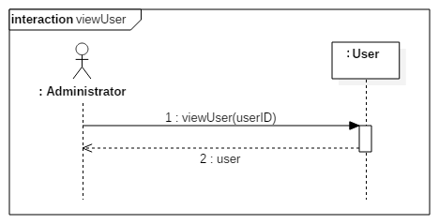

*Figure 5.14.2 viewUser contract diagram*

**5.15 Use Case 15 – Update User**

**5.15.1 Fully Dressed Use Case**

|  |  |  |
| --- | --- | --- |
| Use Case ID: | UC15 | |
| Use Case Name: | Update User | |
| Created By: | Philip Lim | Last Updated By: Philip Lim |
| Date Created: | April 2, 2016 | Last Revision Date: April 2, 2016 |
| Actor(s): | Administrator | |
| Goal/Actor Goals: | Update information related to a user. | |
| Description/Summary: | An administrator wishes to update information saved about a user. Those include the username, first name, last name, net name, password and privilege. | |
| Preconditions: | * User must be logged in as an Administrator. * A user search result is displayed. * The user the administrator wishes to update is listed in the search result. | |
| Post-conditions: | The updated information of the user is displayed in a form of a table. | |
| Minimum Guarantee: | The user’s profile fails to be updated and an error is displayed. | |
| Basic Flow: | 1. Administrator indicates that the information about a specific user must be updated. 2. System displays the update fields filled with the current information about the selected user. 3. Administrator changes and saves the new information about the user. 4. System displays the updated profile of the user. | |
| Risk assessment: | Medium | |
| Importance assessment: | 3/5 | |

**5.15.2 System Sequence Diagram**

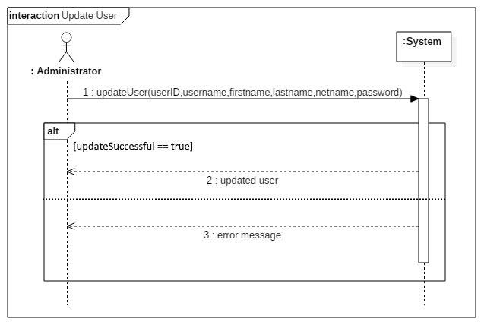

*Figure 5.15.1 Update User System Sequence Diagram*

**5.15.3 Contract Diagram**

|  |  |  |
| --- | --- | --- |
| Contract 15.1 | updateUser | |
| Created By: | Philip Lim | Last Updated By: Philip Lim |
| Date Created: | April 2, 2016 | Last Revision Date: April 2, 2016 |
| Operation: | updateUser(userID,username,firstname,lastname,netname,password) | |
| Cross-reference: | UC15 | |
| Preconditions: | * User is logged into the system as an Administrator. * A search result is displayed * The user that corresponds to the userID is displayed on the search result | |
| Post-conditions: | * The user’s information is updated with the new one passed as parameters. | |

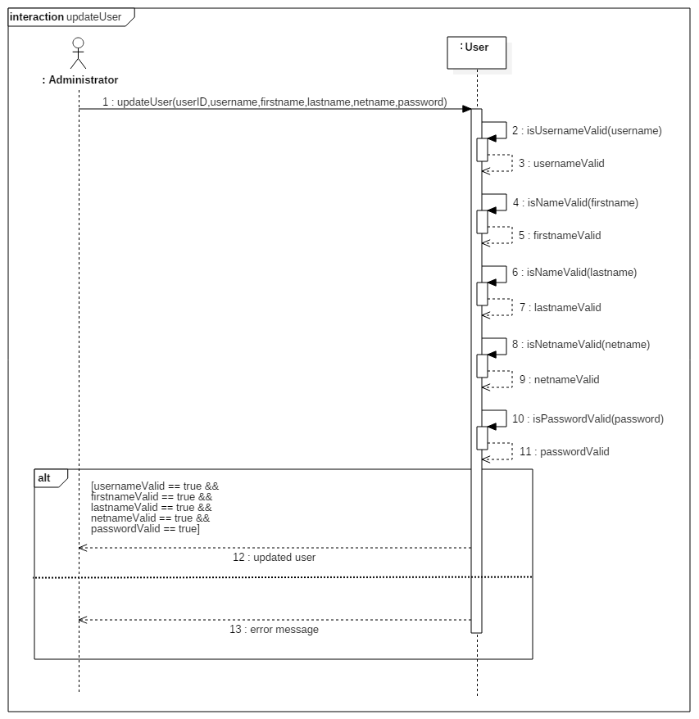

*Figure 5.15.2 updateUser contract diagram*